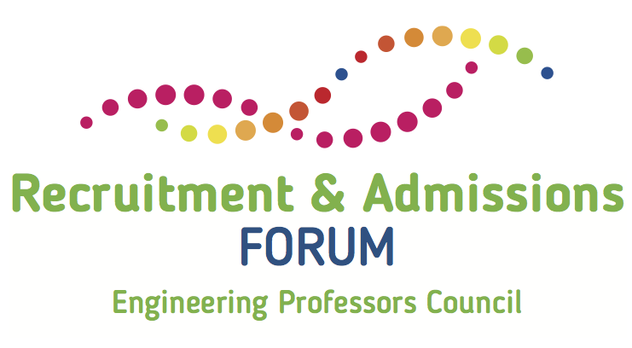

15th November 2017

Manchester Metropolitan University

9.30 - 10.00 | Registration and refreshments
10.00 - 10.15 | Welcome  Georgina Harris, Manchester Metropolitan University
10.15 - 11.00 | Keynote: Is ‘engineering’ a broken brand for applicants?  Mary Curnock Cook OBE
11.00 - 12.15 | Workshop: What entry requirements do you need?  Dr Neil Cooke, Birmingham University  Prof William Heath, Manchester University
12.15 - 12.45 | Creating ‘superdegrees’: Degree apprenticeships  Professor Mike Sutcliffe, Kingston University
12.45 - 1.30 | Lunch
1.30 - 2.15 | Launch of the EPC Engineering Enrolments Survey 2017  With key findings presented by Stella Fowler, EPC
2.15 - 3.15 | Workshop: How do we attract under-represented groups to engineering?  Dr Sarah Peers, Women’s Engineering Society  Jamie Bytheway, Greater Manchester Higher
3.15 - 3.50 | Keynote: What works in access?  Professor Les Ebdon CBE, Director, Office of Fair Access
3.50 - 4.00 | Roundup and close

Please note the Twitter hashtag: #EPCRAF17
Please join the discussion on Padlet at http://bit.ly/epcraf17 or use the QR code (Password: rac2017)

