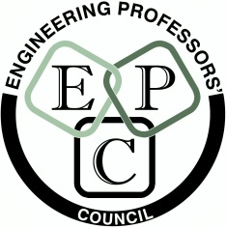

The Engineering Professors’ Council and The Incorporation of Hammermen of Glasgow
Student Awards

SUBMISSION FOR CONSIDERATION FOR THE AWARD OF THE PRIZE
FOR BEST STUDENT ESSAY ON THE TOPIC:

How does engineering contribute to the UK economy and how can that contribution be increased? Is there a role for UK engineering in higher education in making this happen?

CLOSING DATE: Noon on 8th January, 2014

FORENAME:
FAMILY NAME:
EMAIL ADDRESS:
DAYTIME TELEPHONE NUMBER:
NAME OF UNIVERSITY AT WHICH YOU ARE A CURRENT STUDENT (as at 1st December, 2013):
NAME OF AWARD FOR WHICH YOU ARE STUDYING (BSc, BEng, MEng, MSc, PhD etc and subject):
ABSTRACT (no more than 250 words):

DECLARATION
I confirm that this work is original and has not been published previously in any form. I am willing and available to deliver a presentation based on my essay, should it win first prize, on 9th April, 2014 at the Engineering Professors' Council Congress in Glasgow.
SIGNATURE (scanned):

